To: Clinical Users of Centrifugal Pump System CP5

Subject: Update to Instructions for Use – Centrifugal Pump System CP5

Dear Customer,
As part of LivaNova’s ongoing commitment to continuous improvement and user support, we are writing to inform you of an upcoming update to the Instructions for Use (IFU) for the Centrifugal Pump System CP5.
The CP5 System is a cardiopulmonary bypass speed control device indicated for speed-controlled pumping through the cardiopulmonary bypass circuit, in combination with Electrical remote-controlled arterial tubing clamp.
This update consists in the revision of Section: “Messages on the system panel” of Chapter 5 of the IFU (Figure 1), to include additional clarification regarding the technical alarm message “Arterial clamp is defective” and specifically:
- A brief explanation of the conditions under which this message may appear.
- A recommendation to contact technical service for inspection of the clamp when this message is displayed.

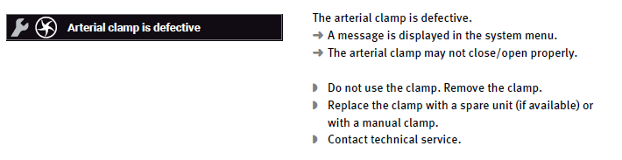
Figure 1: Arterial clamp is defective alarm message.
The revised IFU is not aimed at addressing any identified safety concern as it does not introduce new safety information, and it is not associated with any regulatory action. Specifically, this letter is not intended to prevent or reduce the risk of serious incident in relation to the use of Centrifugal Pump System CP5. The update is intended to support users in their routine interaction with the system, reflecting LivaNova’s commitment to maintaining high standards of technical communication and support to users.
No action is required on your part. The updated IFU will be made available through your local LivaNova representative.
Should you have any questions, please contact your local LivaNova representative.

